Title: Template for preparation of full manuscript for SET [Use “Title”: Arial 18 bold + 100pt paragraph spacing before, and 12pt after]
Subtitle: all manuscripts should follow this template (write a subtitle if needed) [Use “Sub-title” style: Arial 16, ‘auto’ spacing before and after]
Firstname Surname of author¹, Firstname Surname of author², Firstname Surname of author³ [use “name of authors” style: arial12, 18 pt before – 12 pt after]
¹ Affiliation name, affiliation address, author email address [use style “affiliation”: Arial 9 – 3 pt before and after]
² Affiliation name, affiliation address, author email address [use style “affiliation”: Arial 9 – 3 pt before and after]
³ Affiliation name, affiliation address, author email address [use style “affiliation”: Arial 9 – 3 pt before and after]

Abstract: This document explains how to prepare a full manuscript submission for SET. We request that ALL authors follow this template in order to be included in the conference proceedings. Read these notes carefully all the way through and follow them as precisely as possible. This MS Word document should be used as a template. The text in green is there only to give you an overview of the required layout and must be deleted in your final paper. Your text should always use one of the ‘Word styles’ available in this file. You can find the ‘styles’ under the tab ‘Home’ for MS Word version 2007 onwards. The abstract should summarise the context, intent, methods, finding and conclusions of the paper and be between 250 and 350 words. Please do not exceed the maximum word count. [Use style Abstract: Arial 9, italic, 18 pt before – 6 pt after]

Keywords: up to 5 words that identify your paper [Use style “Keywords”: Arial 9 italic – 0 pt before - 12 pt after, max 5 keywords]

INTRODUCTION [arial 10 capitals bold – use “Heading 2” style – ‘auto’ SPACING before and after]
This document explains how to prepare a full manuscript submission for SET. We request that ALL authors follow this template in order to be included in the Conference Proceedings. These instructions apply for all papers.
This MS Word document should be used as a template. The text in green is there only to give you an overview of the required layout and must be deleted in your final paper. Your text should always use one of the ‘Word styles’ available in this file. You can find the ‘styles’ under the tab ‘Home’ for MS Word version 2007 onwards. [Arial 9 – use “Text” style – ‘auto’ spacing before and after-Single line spacing-Justified text alignment]

PREPARING THE MANUSCRIPT
Please prepare your paper in the light of the considerations below to ensure it can be included in the conference proceedings.

Length of paper [ARIAL 10 BOLD – use “Heading 3” style – ‘auto’ spacing before and after]
The final paper should not exceed 10 pages including the front page (title and abstract) and the references. The pages have been set up in A4 size (210 mm x 297 mm) with fixed margins that should not be changed. Illustrations cannot occupy more than 50% of the paper.
Papers exceeding the page limit will need to revised and resubmitted.

Organisation of the paper
The title should be informative, evocative and concise, and locate as indicated on this template. Avoid using acronyms in the title. You may include a subtitle in the area indicated.
Precede the body of your paper with an abstract of 250 to 350 words, giving a brief account of the most relevant aspects of your paper, particularly context, intent, methods, finding and conclusions.
Next add a list of maximum 5 keywords that best apply to your paper.
Arabic numerals and decimal numbering are requested for each heading. It will be done automatically when using the pre-formatted styles.
Headings should not exceed 2 levels (Main Headings and Secondary Headings) because this is a relatively short text. Do not divide your texts in small paragraphs with lots of headings as this makes it very difficult to read.
If you feel you need more headings you should not number them but you may make them italic or underlined. For example:
2.2.1 Extra heading *do not use this
Rather use this:
Extra heading
Observing this rule will make your text more fluent and easier to read.

Tables
Tabular presentation of data is an easy way of condensing many items. Tables must carry numbers in the text (Table 1) and captions above it.
ALWAYS put captions in all tables and make sure the tables are readable. ALWAYS mention the table in text, for example, Table 1 presents an example of a clear table.
Table 1: An example of a clear table [Use style “legend table”: Arial 8 – italic – 6 pt before - 3 pt after]
Cases | Living Room | Kitchen | Bedroom
Case 0 | 21% | 12% | 9%
Case 1 | 14% | 10% | 7%
Case 2 | 13% | 9% | 5%
Case 3 | 13% | 9% | 4%
Case 4 | 12% | 7% | 4%
Captions may be done automatically if you right-click on the table or figure and select ‘insert caption’. If captions are done automatically then you may also use the cross-referencing facility (References> Cross-Reference) to cite the Tables, Figures and Equations in the text.

Illustration and photographs
Drawings, graphs and pictures should not exceed 50% of the entire paper content and should be located close to their corresponding citation. In a scientific paper, they are all referred to as ‘Figures’.
As for tables, figures must carry numbers in the text (Figure 1) and caption below it.
Captions should be complete enough to allow appreciation of the illustration without referring to the text. All graphs must include titles and axis titles, as well as key to the colours used. The font used should be large enough to be read clearly when printed.
Make sure that all figures are clear and easy to read.
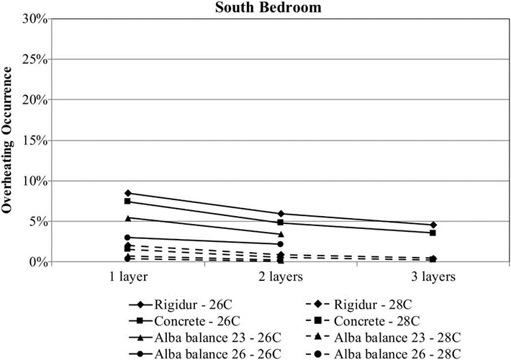
Figure 1: Clear figures are essential [Use style “legend figure”: arial 8 – italic – 6 pts before - 6 pts after]
ALWAYS put captions in all figures and make sure they are readable and clear. ALWAYS mention the figure in the text, for example, Figure 1 presents an example of a clear graph. For figures, the captions are put below. Captions may be done automatically (right click on the Figure, then select ‘Caption’). This facilitates the citation in text through Cross-referencing (under ‘References’ in Microsoft word).

Equations
Equations can be written using the equations tool in MS-Word (Right hand side under the ‘Insert’ tab, if not present read the ‘Using’ notes with this template).
As for tables and figures, equations must carry numbers in the text (Equation 1).
Equations should come with explanations of its components and units.
$E=c_{p}pdt m$ (1)
Where: [Use style “List Paragraph”: Arial 9]
- E = energy (kJ)
- c_{p} = specific heat of water (kJ/kgºC) (4.2 kJ/kgºC for water)
- dt = temperature difference between the hot water and the surroundings (ºC))
- m = mass of water (kg)

References and copyright
References should not appear as footnotes; they should be listed together at the end of the text in the ‘Harvard Style’. If in doubt, please refer to the guide accompanying this Template: GUIDE-Use of Template Full Paper SET
References should appear in the text as (Author Surname, YEAR). It is also important that you put the page number that you are referring to with precise information (Author Surname, YEAR: page XX). It is not acceptable to submit a paper that is not properly referenced.
All data and figures must only be used in agreement with the copyright holders. It is the authors’ responsibility to seek permission and written confirmation that data and/or images produced by others can be used in their papers. Please note that failing to do this may results in having your paper removed from the conference proceedings and/or special issues in our partner journals.

LAYOUT AND SPECIFICATIONS
SET organisers will be strict with layout since all accepted papers will be published in the book of conference proceedings. Please use this template or we may have to request you to revise the format of your paper.

Using the Format Painter
If you use the predefined styles (Home> Styles), all the texts will be automatically adapted. If you are in doubt you can use the ‘Format Painter’ tool to match the properties of 2 texts. It looks like this:
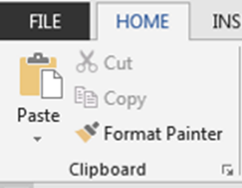
Figure 2: The format painter tool
Select the text with the format you wish to copy onto another bit of text. Click on the ‘Format Painter option as shown above then using the L mouse button and keeping it pressed, ‘drag’ across the text you wish to reformat into the selected format.

Page size
Page size must be A4 Size (210 mm x 297 mm). The margins should be top - 15mm, bottom - 15mm, left -15mm and right - 15mm. These should not be changed because your paper will be a chapter in the book of proceedings that will follow this format.

Headings
The section headings should be typed in capital letters, the subsections in upper and lower case. Do not underline headings or words within the text. Please follow the template instructions above

SUBMISSION INSTRUCTION
Please upload your paper using the EasyChair system. Papers submitted via email will not be accepted. Easychair will automatically rename and number your paper sequentially and email the Corresponding Authors with the Paper ID. You must submit your paper for review as an editable WORD document so that it can be part of the book of proceedings.

SOME COMMON MISTAKES You SHOULD AVOID
All figures, tables and equations should have a numbered caption and be referred to in the text.
The word “data” is plural, not singular. A parenthetical statement at the end of a sentence is punctuated outside of the closing parenthesis (like this). Reference citations should be within the sentence they refer to, i.e. before the punctuation. For example (Rodrigues, 2009).
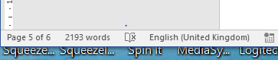
Please check your spelling using UK English language. You can check and set the language from the lower bar of the Word window as here:
To change the language if it is incorrect click on the language name in the Word windows and select ‘English (United Kingdom’.
Please avoid simple mistakes such as: there is no period after the “et” in the Latin abbreviation “et al.”; the abbreviation “i.e.” means “that is,” and the abbreviation “e.g.” means “for example”.
Do not divide your work in too many parts (this template is not an example as it does not contain enough text). It should read as a full text and there is no need for a title for each paragraph. Do not use unnecessary italic, bold or underline, neither Capital Letters When Not Needed (This Is Frustrating To Read).
Do not use informal language. Write in the past tense as in: ‘this work was undertaken…’, ‘measurements indicated that…’. Remember your report does not say anything, you do! So use ‘In this article, the author has shown…’ rather than ‘This articles showed that…’.

CONCLUSION
In conclusion, you may clearly restate the key findings to remind the reader of the purpose of your study. Briefly mention the limitations of your study to provide a balanced perspective.

REFERENCES
In the text use the author's surname and the date followed be the page where the information was found. References should then be listed alphabetically by author at the end of the work, with the date placed immediately after the author's name.
Author surname, Author initial(s), YEAR. Title. Edition. Place: Publisher. Number of volumes.
Author surname, Author initial(s), YEAR. Article title. Journal title, volume number (part), page numbers.
Author surname, Author initial(s), Author name, YEAR. Conference Name/Title. Place: Publisher.

Refer to the GUIDE-Use of Template Full Paper SET for full instructions on referencing.
CHECK LIST - please ensure that you:
- Have observed the page limit
- Have observed the requested format
- Have checked the spelling and grammar of the text
- Have used formal academic language in the past tense
- Have not overused CapiTal LETTERS, bold, italic or underline
- Have put captions in figures, tables and equations, and have mentioned them in the text
- Have split the text only when vital and the titles are concise and reflect the section it heads
- Have made sure there are no contradictions
- Have coherently described simulation/experiments cases (if any) and they are easy to follow
- Have made sure that the conclusions reflect only the findings of the paper and not knowledge gained elsewhere
- Have used the correct format for references
- Have made sure there are no speculative statements which are not supported by the work undertaken or references
- Have correctly referenced statements, quotes, ideas and figures that were not produced by the authors
- Have ensured the abstract summarises the context, intent, methods, finding and conclusions of the paper

